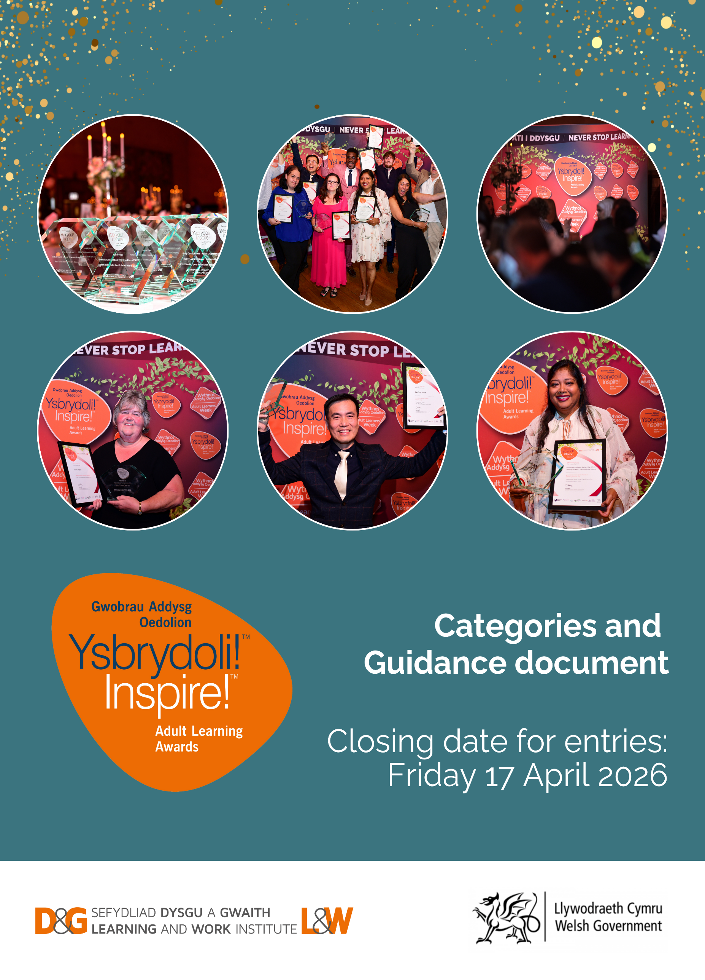

This document is available in Welsh.
What are the Inspire! Adult Learning Awards?
Lifelong learning benefits everyone and it has the power to change lives.

The Inspire! Adult Learning Awards celebrate the achievements of people and community projects in Wales who have experienced the transformational power of learning, embraced second chances, and unlocked new possibilities. They highlight the impact of adult and lifelong learning, demonstrating the value of investing in life-changing opportunities.
We are working with partners to inspire more people to take up lifelong learning opportunities and to share their achievements and the many benefits that come along with learning new skills.
The awards are organised by Learning and Work Institute, in partnership with Welsh Government and other partners.
The awards ceremony will take place as part of Adult Learners’ Week.
Inspire us by making nomination:
We are looking for individuals and projects whose learning achievements will inspire others to return to or take up learning. People who have improved their lives and /or the lives of others and gained a positive or life-changing experience from adult learning.
2026 award categories:
- Skills for Work Award
- Young Adult Learner Award
- Life Change Award
- Essential Skills for Life Award
- Learning for Better Health Award
- Ageing Well Award
- New Welsh Speaker Award
- Shared Futures Award
- Hywel Francis Award for Community Impact
- Learner Voice Award

A guide to submitting your nomination:

- Entries are free and open to individuals and organisations living and working in Wales
- Learning can be accredited or non-accredited and can take place in a variety of settings, including workplaces, higher education institutions, further education colleges, online platforms, in the home, and local communities.
- Anyone aged 16 or over can nominate / be nominated for an Inspire! Award, please refer to the guidance on each category.
- At Learning and Work Institute we are dedicated to supporting equality and diversity and to improving access to education for all groups. We welcome nominations from all backgrounds and with all different kinds of life experiences and abilities.

- Entrants for the individual categories must be nominated by another person – this could be a friend, mentor, a colleague, family member, or employer who is well known to the individual nominated.
- Entries for the project categories should be written by a team or project leader and endorsed by a senior manager or referee who knows the provision well. We also welcome statements from learners and employees involved in the project to support the nomination.
- Your application will be judged on the information you provide in your entry so please make sure you read the Inspire! Awards category guidance below to help with this and include as much detail in your statements. Supporting documents are also welcome.
- We understand that sharing experiences can be a deeply personal and sometimes challenging decision. Please know that the nominee is under no obligation to disclose every detail of their personal circumstances. We encourage them to share their story to the extent that it feels comfortable and safe. If your nominee's story involves complex safeguarding concerns, please review this before you submit and be assured that we will work closely with you to prioritise their well-being.
- Both nominee and nominator statements must be completed.

Closing date for entries: Friday 17th April 2026

How does the selection process work?

- An independent panel of judges from the adult learning sector will select the final category award winners.
- Nominees who are shortlisted may be contacted again prior to the final selection panel meeting to clarify or provide further information to support their nomination.
- Selected award winners will be invited to an awards ceremony to celebrate their achievements. Their stories will also be shared through various media channels, including film, photography, and press releases.
- The nominators of all Inspire! Award winners will be notified by end of June 2026.
- We would like any nomination for the Inspire! Awards to be a catalyst for celebrating the stories of adult learning. We would encourage anyone nominating for the awards to use the process to celebrate each nominee with local/regional award ceremonies and to join the Adult Learners' Week festival to do this.

There are three ways to submit your nomination:
Email - please complete our Word document nomination form and send it to us by email: inspire@learningandwork.org.uk, including any supporting information/photos.
Online – Use our online nomination form to submit your entry. The form allows you to save your progress as you work, so you can complete it at your convenience. We recommend preparing
your nominator and nominee statements in advance and then copying and pasting them into the online form. The word count for statements is approximately 800 words.

Film – Share your transformative learning experience through a compelling video clip of up to five minutes. Complete sections one, three and four of the Word version of the nomination form and email us both the nomination form and the video link: inspire@learningandwork.org.uk.

Inspire! Awards 2026 categories:
Discover the inspiring journeys of past winners by clicking on the links below each of the category descriptions.
Skills for Work Award
For many people, the incentive for developing their skills is to improve their job prospects, to progress in their careers or to help return to work after a period of not working. Fair work offers people the opportunity to continue to learn and develop skills in the workplace, leading to progression and sustainable employment.

This award recognises an individual who can demonstrate outstanding determination to improve their experience of work through learning and who can demonstrate the role that learning has played in securing a job or achieving progression in work.
Will Hougham – 2025 award winner
Isaac Fabb – 2024 award winner

Young Adult Learner Award
For some the first experience of education is not always positive but many young people return to post-compulsory education because they want to make a positive change and build a better future. Some young people may not have been able to fully engage with school because of caring responsibilities or may have experienced disruption in their lives for other reasons.

The winner of this award will be a person who has shown real commitment to their own learning journey, and who is one to watch for the future! This award is open to any learner aged between 16 – 25 (we particularly welcome nominations on behalf of care experienced young people, care leavers and young carers).
Osian Lloyd - 2025 award winner
Sophie Dey – 2024 award winner
Life Change Award
Lifelong learning opens doors to new opportunities and empowers individuals to thrive in a rapidly changing world. As the population grows and ages and new technology develops, we are all working for longer, changing careers more often and learning new skills throughout our lives.
This award recognises an adult learner who has embraced lifelong learning and can demonstrate lifechanging experiences of learning. They will have taken up opportunities to re-engage with education and continue to learn and progress. The winner of this award may be someone who has progressed through different levels of learning, demonstrates a passion for engaging with education and training, showing that it’s never too late for a second chance, a new direction or a fresh start.
Ida Aldred – 2025 award winner
Daniel Morgan – 2024 award winner
Essential Skills for Life Award
Literacy, numeracy, ESOL, digital, financial capability, health literacy and citizenship are central to people’s job and career prospects, wellbeing and ability to be active and engaged in their communities. Economic and social changes, and the advancement of technology, are increasing their importance.

This award winner will demonstrate the impact of building essential skills and the transformation it can have. This may be increasing confidence, accessing work or work progression, participating in family learning provision, the ability to engage more with public services and social interactions.
Janine Price – 2025 award winner
Vale People First Men’s Group – 2023 award winner
Learning for Better Health Award
Learning and skills are a key to tackling health inequalities. It boosts confidence, supports mental and physical health, fosters social connections, and equips people with the skills they need to thrive throughout life.

This award celebrates an adult learner who has improved their health and wellbeing – they may have overcome health challenges or managed chronic conditions. They have engaged with learning as part of their recovery, or they may have been signposted to learning provision by a healthcare professional. This award will focus on the benefits of learning to support health and wellbeing; the award winner may demonstrate the value of social prescribing and a preventative approach to healthcare.
Mandy Price – 2025 award winner
Eve Salter - 2024 award winner

Ageing Well Award
Learning in later life can make a significant contribution to tackling loneliness, feeling connected, building confidence, keeping active and living well.

This award recognises the value of continuing to learn and gain new skills into older age, it will demonstrate the contribution that many older people make to lifelong learning.

The award winner should demonstrate why they have continued to learn or engage in learning in later life. They may be active in sustaining self-organised learning in their community or maybe passing on their skills across generations. This award celebrates learners over the age of 60.
Gloria Beynon – 2025 award winner
Tony Morton – 2024 award winner
John and Val Snare – 2022 award winners

New Welsh Speaker Award
The ambition in Wales is to create a million Welsh speakers by 2050. For adults, there are opportunities to learn online, through a community class or in the workplace.

This award recognises an individual who has made a start at learning Welsh by following a Learn Welsh course at Entry or Foundation level. We aren’t expecting the award-winner to have fully mastered the language; however, we would like entrants to have demonstrated a commitment to developing their skills in Welsh and to using the language with their family, in their community or workplace.
Foo Seng Thean – 2025 award winner
Daniel Minty – 2024 award winner
Shared Futures Award
Wales has a proud history of welcoming people from all over the world, including refugees, migrants, and those seeking sanctuary. This award is about celebrating the incredible achievements of individuals who have chosen to make Wales their home and the contributions they bring to our communities.

We’re looking for someone who has embraced learning, developed new skills, and used these to move forward into further education, work, or volunteering. This award is a chance to shine a light on their hard work, resilience, and the positive impact they’ve had on the people and places around them.

Hamdi Abdalkareem Abdalla Abdalrhman – 2025 award winner
Inas Alali – 2024 award winner
Hisham Saeed / Zaina Aljumma – joint award winners 2022
Hywel Francis Award for Community Impact
For many people, the route back into learning starts close to home, in a community venue, or as part of a community project. Many community projects provide a place-based approach to tackle social isolation, remove barriers to learning and provide pathways into learning and skills. They recognise the role of education as a key enabler that will give communities the confidence and connections they need to succeed.
The winner of this award will be a community project run by an individual or organisation.
The project must be successfully transforming lives through the creation of community-based opportunities that reach out to people who would not otherwise engage in formal or informal education and skills development.
Parent Learning Group (Cathays High School) – 2025 award winners
Compass Community Hub – 2024 award winner
Families Learning Together CAVC – 2023 award winner
Learner Voice Award
This award winner will be selected by a panel of learners.

Our Learner Voice panel will be looking for an individual who has used their learning experience to inspire others or has influenced change and improvements in the delivery of adult learning.

Involving learners in decision making, identifying gaps and better ways of working as well as using their networks to promote opportunities has many benefits.

The winner of this award may have become an advocate for learning at a national or local level. They may be active in their community, encouraging, supporting and signposting to opportunities. They may be involved at any level in sharing their experiences to inspire, mentor and guide others. They may be able to demonstrate that they are using their experiences to spark change and improvements in provision.

Gina Powell – 2025 award winner

